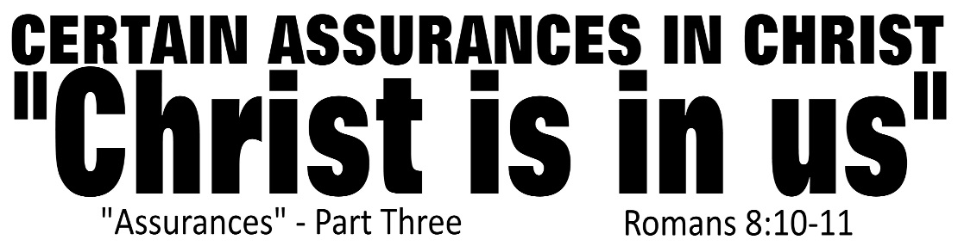

Dr. Joe K. Taylor, Senior Pastor, South Reno Baptist Church, Reno, NV January 25, 2015
All Scriptures are printed verbatim with translations noted. Pew Bible Page Number is 1041.
In the Study Verse Section, God’s Word is printed in regular faced text with Pastor Joe’s commentary in the smaller faced text.
Biblical words, underlined with dots, are explained in the brackets.

1. There were four contrasts made in the text: Flesh vs. Spirit; Death vs. Life; War with god vs. Peace with God and Pleasing Self vs. Pleasing God.
2. As a following of Christ, we can be certain that we are pleasing to God. (He looks past us and sees only His son, Jesus in us.)
3. “There comes a time in a man’s life when he must prove what he believes by what he does.”
4. We can live according to the “flesh” (which leads to death) or live according to the Spirit of God is us (which leads to life and peace.)

If Christ is “in” us, something changes:

1. Spiritually, the present is changed.
Romans 8:10, NASB95 - ¹⁰ If Christ is in you [the word “you” is plural; phrase “Christ is in you” is in the present tense], though the [physical] body is dead [nominative case, “will die” denoting something that will eventually die, “has the seeds of death in it and will die” (ATR)] because of sin, yet the spirit [human spirit (note that the HCSB does not capitalize this word, the NASB does] is alive [present tense, active voice, indicative case, “currently” the human spirit is alive because Christ is alive in it] because of righteousness.

2. Physically, the future is changed.
Romans 7:24, NASB95 - ²⁴ Wretched man that I am! Who will set me free from the body of this death?

Romans 8:11, NASB95 - ¹¹ But if the Spirit of Him who raised Jesus from the dead dwells in you, He who raised Christ Jesus from the dead will also give life [future tense, active voice, indicative mood; lit., “to cause to live, make alive, give life”] to your mortal bodies through His Spirit who dwells in you.

Life Application Section:

Assurance of Salvation: “That settled confidence that occurs when one realizes they have indeed surrendered their lives to Christ who alone guarantees that the gift of salvation, once received, is forever and cannot be lost.”

How can a true believer be confident they have eternal life?

A. Direct statement from the Holy Word of God.

Ephesians 1:13–14, NIV84 - ¹³ ….Having believed (in Christ), you were marked in him with a seal, the promised Holy Spirit, ¹⁴ who is a deposit guaranteeing our inheritance until the redemption of those who are God’s possession—to the praise of his glory.
Ephesians 4:30, NASB95 - ³⁰ Do not grieve the Holy Spirit of God, by whom you were sealed for the day of redemption.
John 5:24, NLT - ²⁴ “I tell you the truth, those who listen to my message and believe in God who sent me have eternal life. They will never be condemned for their sins, but they have already passed from death into life.
John 10:27–28, NASB95 - ²⁷ “My sheep hear My voice, and I know them, and they follow Me; ²⁸ and I give eternal life to them, and they will never perish; and no one will snatch them out of My hand.
1 John 5:13, NASB95 - ¹³ These things I have written to you who believe in the name of the Son of God, so that you may know that you have eternal life.

B. The witness of the Holy Spirit of God.
Romans 8:16, NIV84 - ¹⁶ The Spirit himself testifies with our spirit that we are God’s children.

C. An outward evidence of an inward change.
2 Corinthians 5:17, TLB - ¹⁷ When someone becomes a Christian, he becomes a brand new person inside. He is not the same anymore. A new life has begun!
As a follower of Christ, you can be certain that you will live eternally with God.

- ²⁰ “So then, you will know them by their fruits.
Matthew 7:20, TLB - ²⁰ Yes, the way to identify a tree or a person is by the kind of fruit produced.

