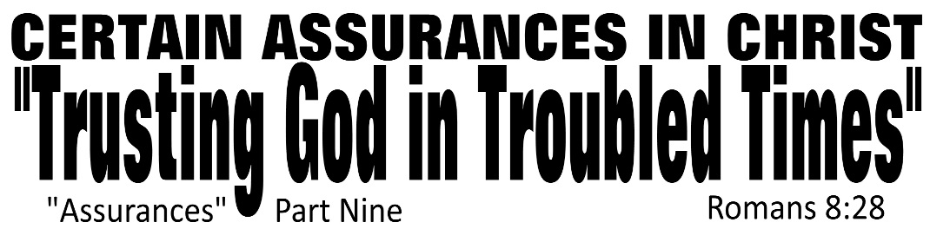

Dr. Joe K. Taylor, Senior Pastor, South Reno Baptist Church, Reno, NV March 8, 2015
All Scriptures are printed verbatim with translations noted. Pew Bible Page Number is 1042.
In the Study Verse Section, God’s Word is printed in regular faced text with Pastor Joe’s commentary in the smaller faced text.
Biblical words, underlined with dots, are explained in the brackets.

1. While the Creation groans to be free from the cursed creation and the Christian groans to be free from these dying bodies, the Comforter—god’s Holy Spirit in us—groans to see the will of the father done is us.
2. As a follower of Christ, you can be certain that God is concerned and will you in the trials you face.
3. God wants to help us and we need His help.

STUDY VERSE SECTION - Romans 8:28, HCSB - ²⁸ We [Paul is talking to the followers of Christ—not the world] know [Gk: οἶδα, oui-da, meaning to know or have knowledge about something normally acquired through reflection or thinking] that all [Gk: πᾶς, pas, lit., every single one—all] things work [Gk: συνεργέω, sūn-ER-géō, sūn means with, ergéō means energy from outside (indicative mood); we get our English word “synergy” from this word together for the good [with a definite article, “THE good”] of those who love [Gk: ἀγαπῶσιν, a-ga-PÓ-sin meaning “to cherish”] God: those who are called [Gk: κλητός, ka-LAY-tós is an aorist, passive, participle of καλέω meaning called, invited, and appointed; “In the NT… generally refers to one who has accepted a calling or an invitation to become a guest or member of a select group] according to His [eternal] purpose.

Romans 8:28, JTT - “To the ones who cherish God and to the same ones invited by God to join in His eternal purposes, He works all things together
for ‘the good.’

T
he believe never need faint in times of suffering and trial because he know that god is at work (Rom. 8:28)…and that He has a perfect plan (rom. 8:29). God has two purposes in that plan: Our good and God’s Glory.”
– Dr. Warren Wiersbe.
Four Things “We Know”

1. There is always some confidential about our troubles.
“We know…”
Deuteronomy 7:9, NIV84 - ⁹ Know therefore that the Lord your God is God; He is the faithful God, keeping His covenant of love to a thousand generations of those who love Him and keep His commands.

2. There is always some comprehensive about our troubles
“…that all things work together…”
Ephesians 1:11, NLT - ¹¹ Furthermore, because we are united with Christ, we have received an inheritance from God, for he chose us in advance, and He makes everything work out according to his plan.

3. There is always some constructive about our troubles.
“…for the good…”
Jeremiah 29:11, NLT - ¹¹ For I know the plans I have for you,” says the Lord. “They are plans for good and not for disaster, to give you a future and a hope.

4. There is always some conditional about our troubles.
“…of those who love God:
those who are called according to His purpose.”
1 Corinthians 2:9, NIV84 - ⁹ However, as it is written: “No eye has seen, no ear has heard, no mind has conceived what God has prepared for those who love him”…

I
As a follower of Christ, you can be certain that God’s hands, intended evil becomes eventual good.
f God promised His servants an unbroken run of prosperity, there would be many counterfeit Christians. Don’t be surprised at suffering…it is permitted to root you deeper just as a strong wind makes the tree grapple deep into the soil. – Dr. F.B. Meyer

Friberg, T., Friberg, B., & Miller, N. F. (2000). Vol. 4: Analytical Lexicon of the Greek New Testament. Baker's Greek New Testament library 232). faGrand Rapids, Mich.: Baker Books.

