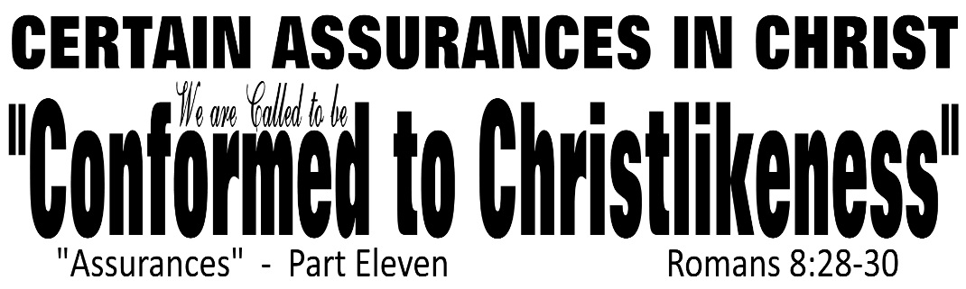

Dr. Joe K. Taylor, Senior Pastor, South Reno Baptist Church, Reno, NV March 22, 2015
All Scriptures are printed verbatim with translations noted. Pew Bible Page Number is 1042.
In the Study Verse Section, God’s Word is printed in regular faced text with Pastor Joe’s commentary in the smaller faced text.
Biblical words, underlined with dots, are explained in the brackets.

1. God FOREKNEW who would be saved and God PREDESTINED those to become CONFORMED to the image of Christ. Those God CALLED to be one of His adopted children, He also JUSTIFIED (treating them as if they had never sinned), and He also promised them the GLORIFIED state (with new bodies) in the future.
2. As a follower of Christ, you can be certain that God calls you to be like His Son—Jesus Christ.
3. God’s will for your life is that you will be more like Jesus today than you were yesterday.

Romans 8:28–30, The Living Bible - ²⁸ And we know that all that happens to us is working for our good if we love God and are fitting into his plans. ²⁹ For from the very beginning God decided that those who came to him—and all along he knew who would—should become like his Son, so that his Son would be the First, with many brothers. ³⁰ And having chosen us, he called us to come to him; and when we came, he declared us “not guilty,” filled us with Christ’s goodness, gave us right standing with himself, and promised us his glory.

A. The believer has a new confidence. (v. 28)
• What it involves--God causes everything to work together for the good.
• Whom it involves—Those who love God and are called by God.

B. The believer has a new calling. (v. 29)
• To be like His Son Jesus Christ—right now!

C. The believer has a new destiny. (V. 30)
• Eternity with God—forever!
The Father Himself has decreed that all believers should become like His dear Son:

Philippians 3:12–14, NASB95 - ¹² Not that I have already obtained it or have already become perfect, but I press on so that I may lay hold of that for which also I was laid hold of by Christ Jesus. ¹³ Brethren, I do not regard myself as having laid hold of it yet; but one thing I do: forgetting what lies behind and reaching forward to what lies ahead, ¹⁴ I press on toward the goal for the prize of the upward call of God in Christ Jesus.

1. The start of the race.
Philippians 3:7–9, NLT - ⁷ I once thought these things were valuable, but now I consider them worthless because of what Christ has done. ⁸ Yes, everything else is worthless when compared with the infinite value of knowing Christ Jesus my Lord. For his sake I have discarded everything else, counting it all as garbage, so that I could gain Christ ⁹ and become one with him. I no longer count on my own righteousness through obeying the law; rather, I become righteous through faith in Christ. For God’s way of making us right with himself depends on faith.

2. The course of the race.
Philippians 3:13–14, NLT - ¹³ No, dear brothers and sisters, I have not achieved it, but I focus on this one thing: Forgetting the past and looking forward to what lies ahead, ¹⁴ I press on to reach the end of the race and receive the heavenly prize for which God, through Christ Jesus, is calling us.

3. The end of the race.
Philippians 3:14, NASB95 - ¹⁴ I press on toward the goal for the prize of the upward call of God in Christ Jesus.

“Our bad turns out for good; our best is yet to come”

Application Section

How do we become like Christ?
1. Be firm and strong in your resolve to follow Christ daily.
2. Exercise humility.
3. Spend time in His word every day.
4. Spend time in prayer every day.
5. Keep in front of you this question: “What would Jesus do?”
6. Keep your life pure from any taint of compromise.

